**Screenshot of application at runtime:**

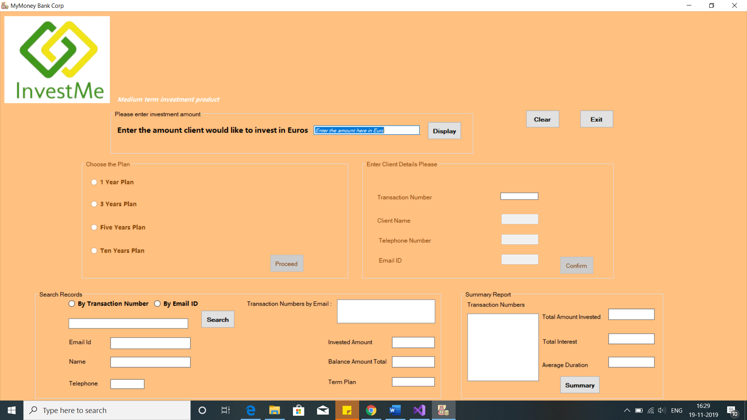

**Fig 1. On the run of application User can enter the investment amount, check the summary and search any past transaction. The Proceed and Confirm button are disabled.**

**Also just on the click of textbutton the investment amount text box is cleared. ToolTips have been added to help the user**

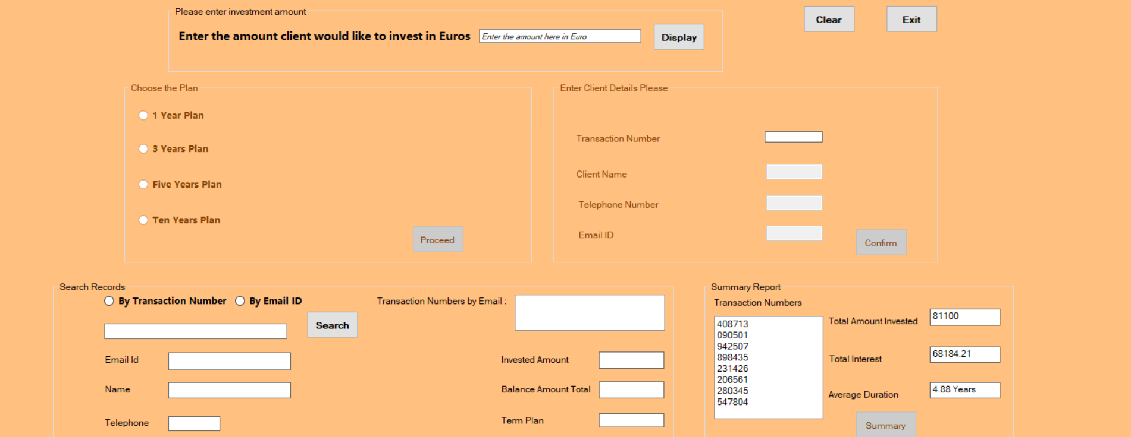

**Fig 2. When user clicks on the summary, all the past transaction is shown in the summary group box. As per requirement Transaction numbers along with Total amount invested and total interest and average duration are shown**

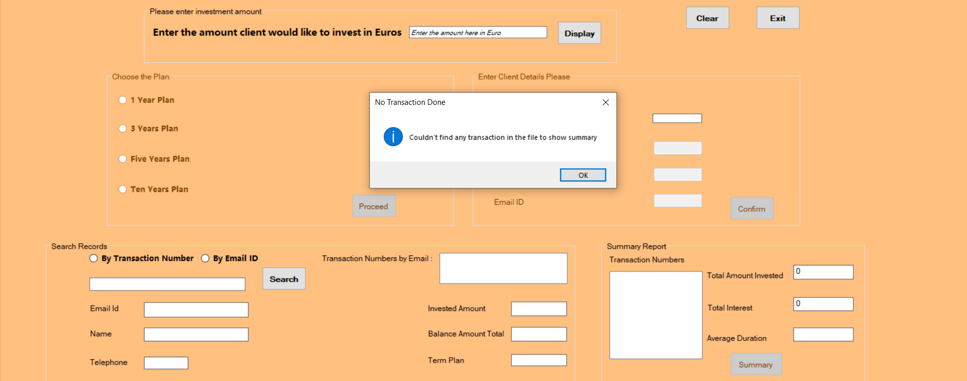

**Fig 3. In case if there’s no transaction and user click on Summary button proper message is shown informing user that no transaction exist in the system.**

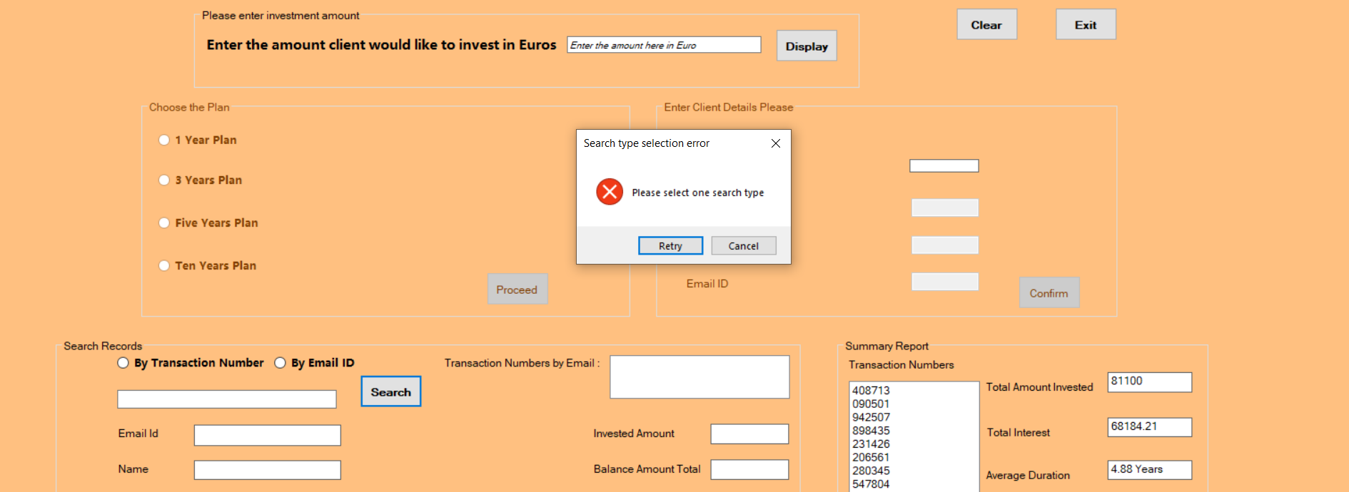

**Fig 4. If user click on search button without selecting the Search by Transaction number or Email-ID then error message is shown that ask user to select the search type**

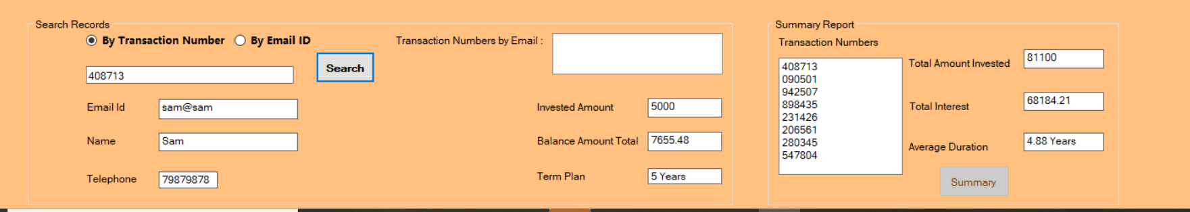

**Fig 5. When user search by transaction number the relevant transaction detail is shown if available**

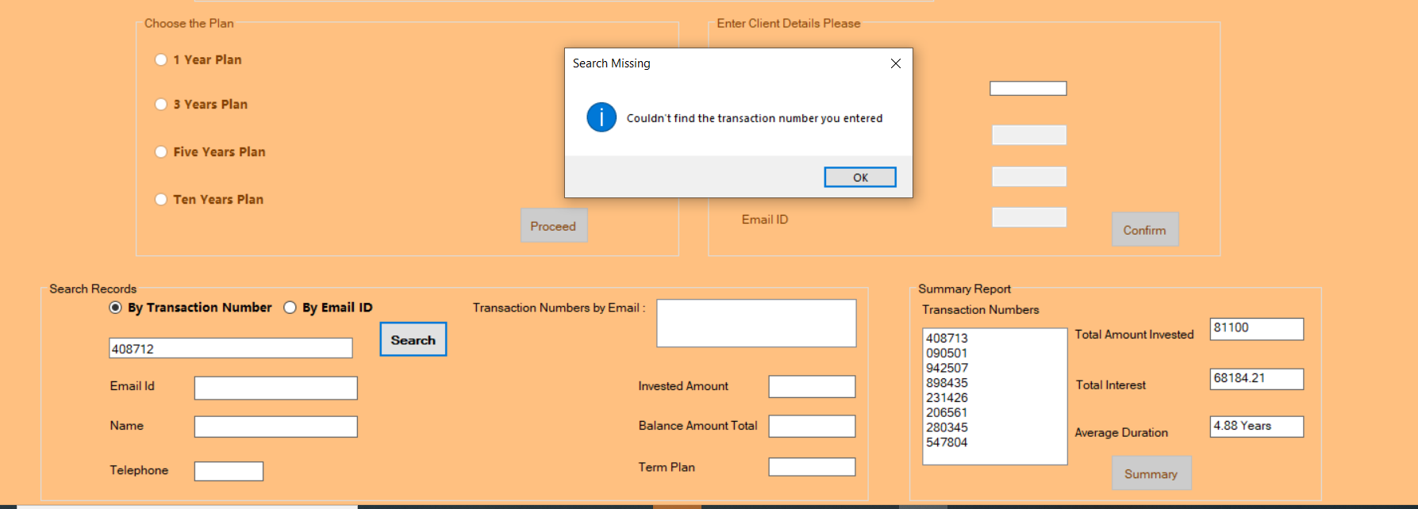

**Fig 6. If the transaction is not present in the file the proper information message is shown to the user**

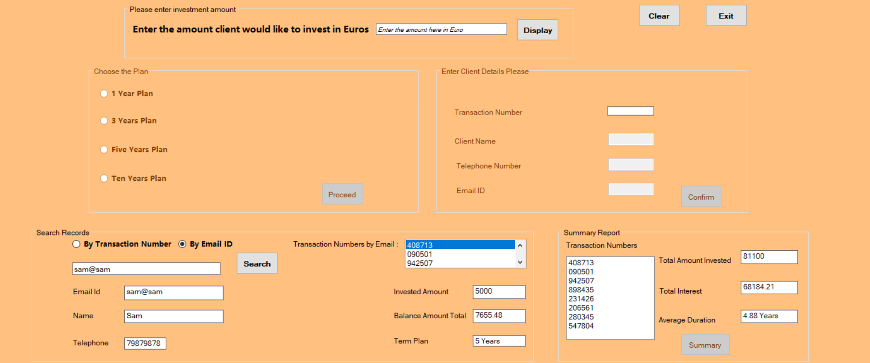

**Fig 7. While you search for multiple transactions using the email id, all the transactions with that email id is shown in the list box and as we scroll through transaction numbers in the list box details of each transaction is shown**

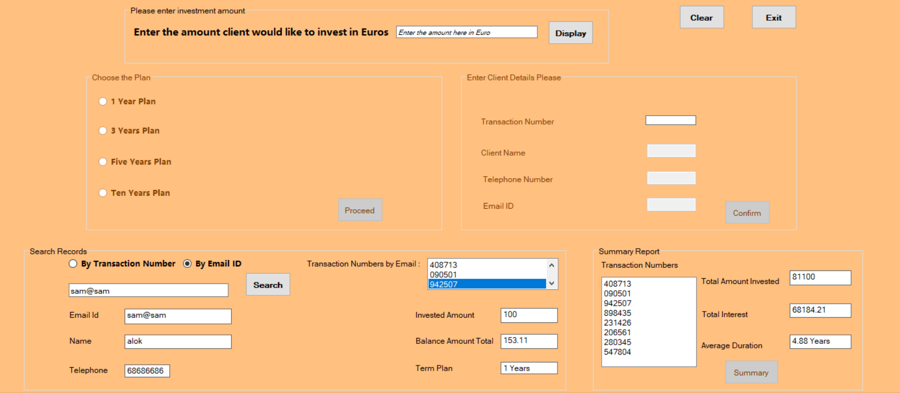

**Fig 8. This shows how on scrolling through different transaction the details changes**

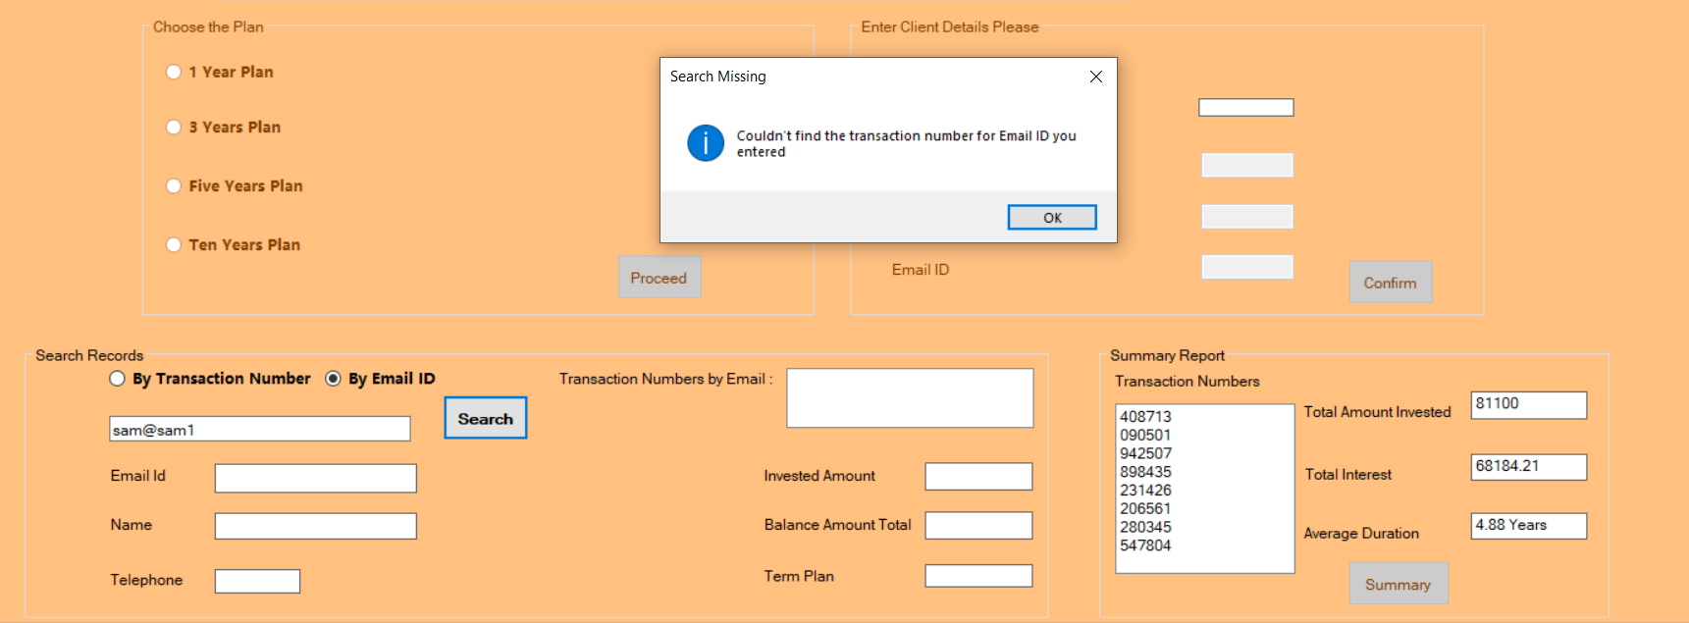

**Fig 9. In case you enter the email id which not exist then it shows the proper error message informing the user. On click of Ok button the application sets back the focus on the search string textbox for user correction**

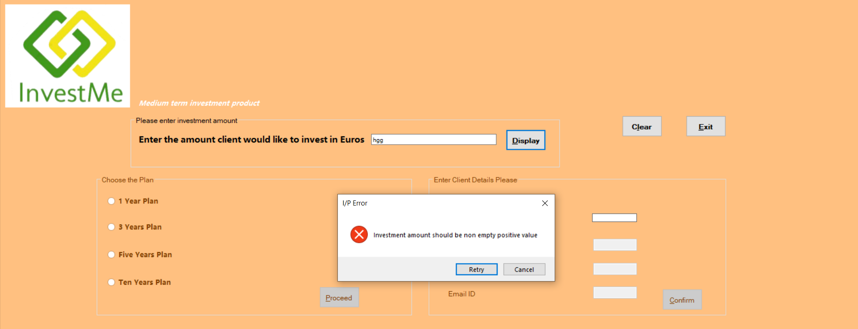

**Fig 9. In case user enters the non-numeric value in the investment amount the error message is shown to the user. It informs the user that Investment amount should be non empty integer positive value. On click of retry the application sets back the focus on investment amount textbox**

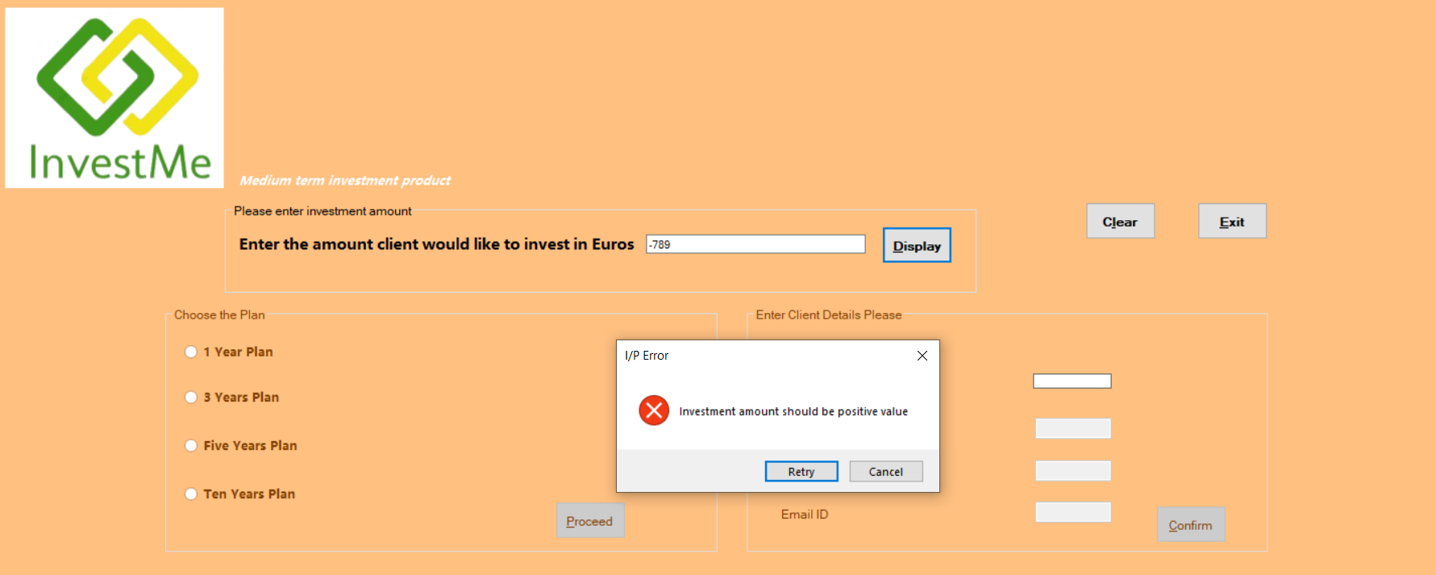

**Fig 10. In case user enter the negative value in the amount the application shows the error message informing user that amount should only be positive**

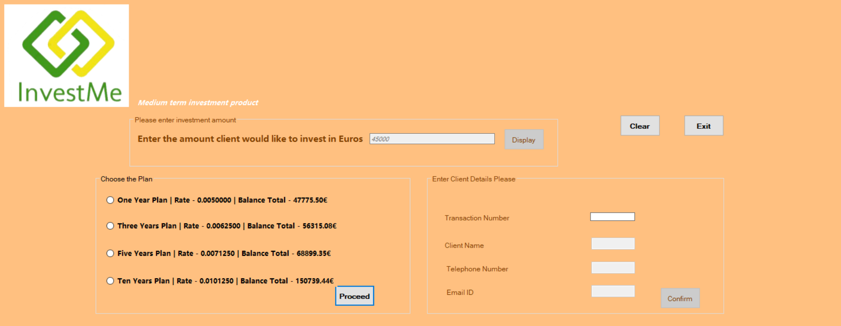

**Fig 11. On click of display button after entering logical amount application takes us to proceed button where we can choose the plan. All the calculation has been done as per requirement and Bonus amount and criteria have been taken into consideration**

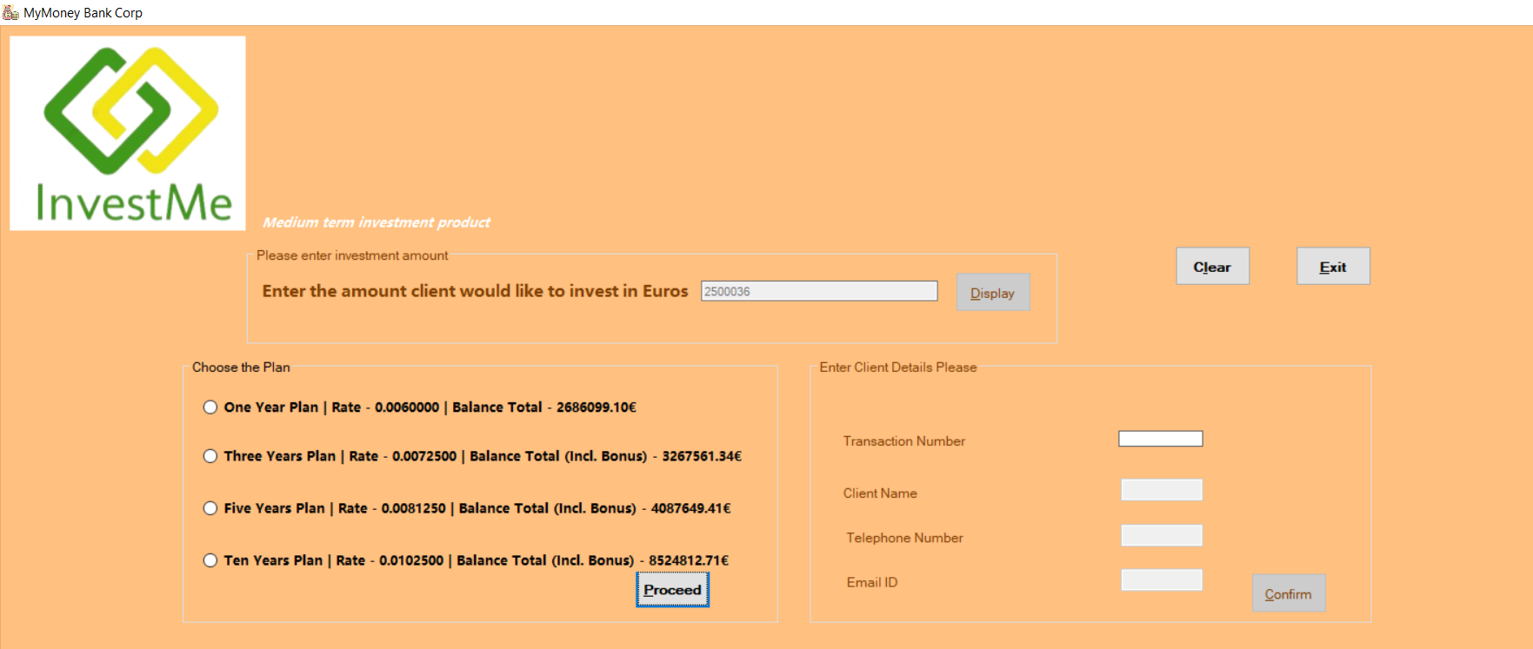

**Fig 12. When amount satisfies the bonus condition**

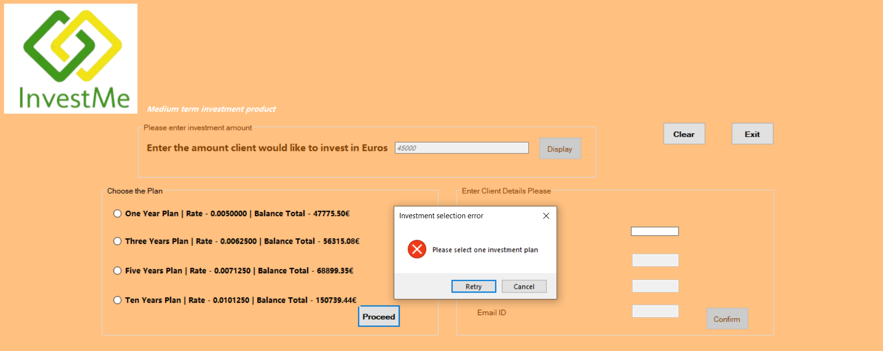

**Fig 13. If user doesn’t select the plan and click on proceed error message is handled which shows user to select the plan**

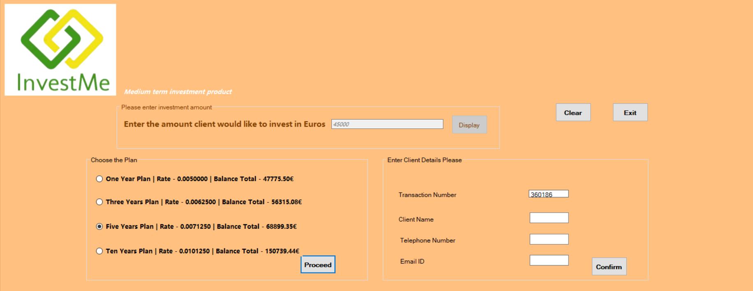

**Fig 14. After the proceed button is clicked the application generates the transaction number and user need to input client details**

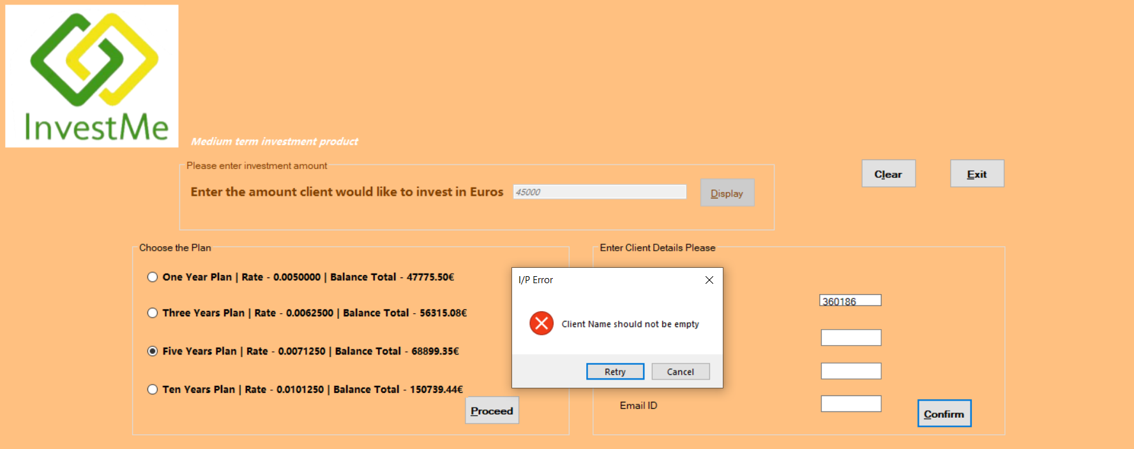

**Fig 15. Exceptional handling is done in case user doesn’t enter client name and click on confirm button**

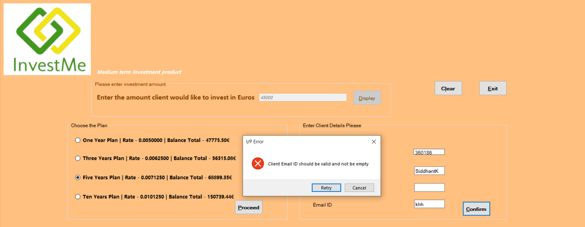

**Fig 16. In case user input invalid email id with no @ then it shows that email id is invalid and ask user to re-enter it**

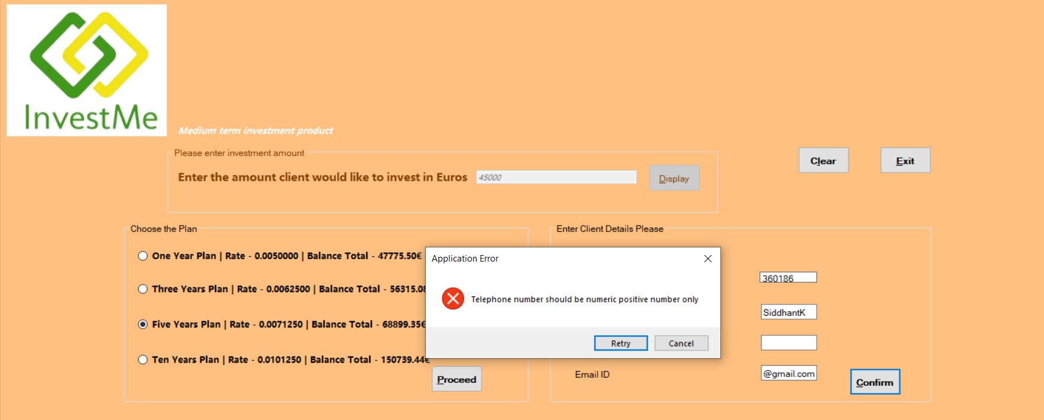

**Fig 17. In case user doesn’t enter the telephone number then a proper error message is shown which asks the user to enter valid telephone number**

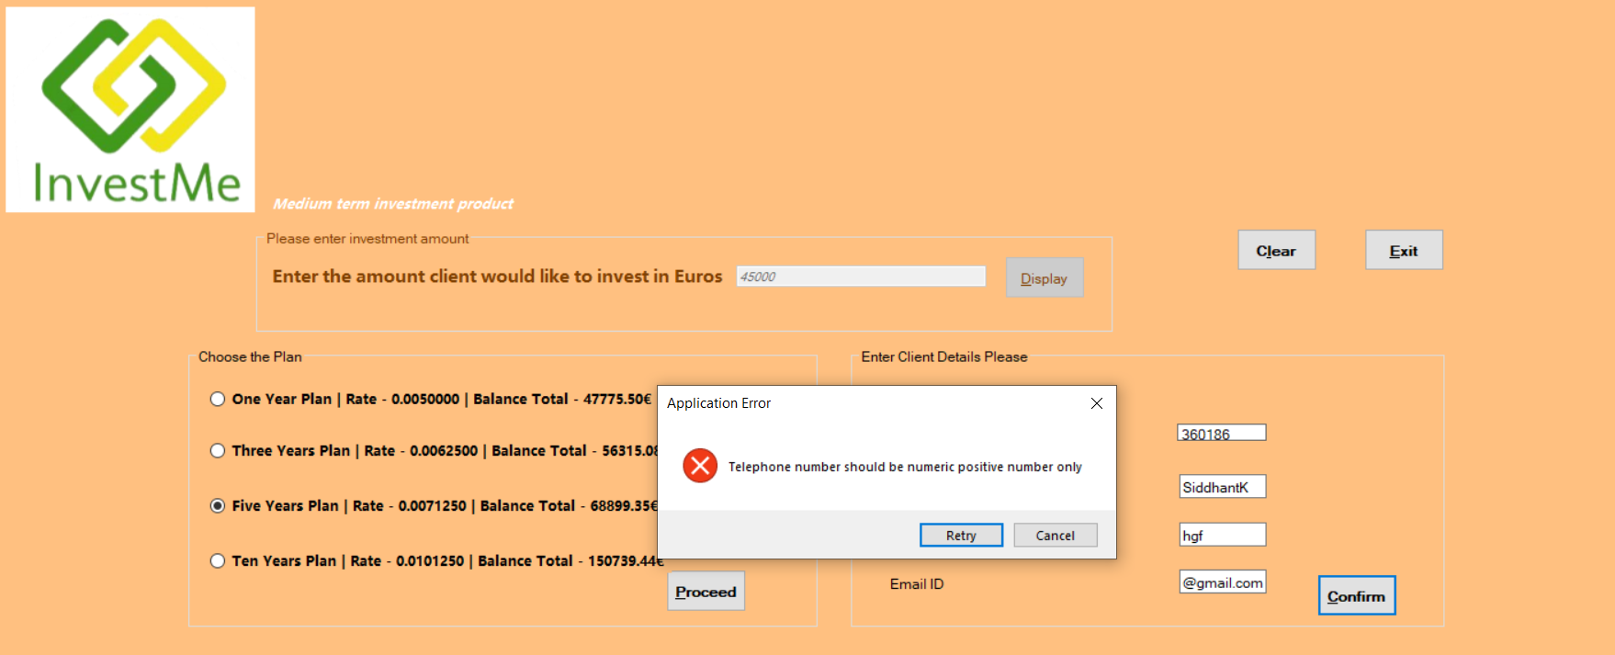

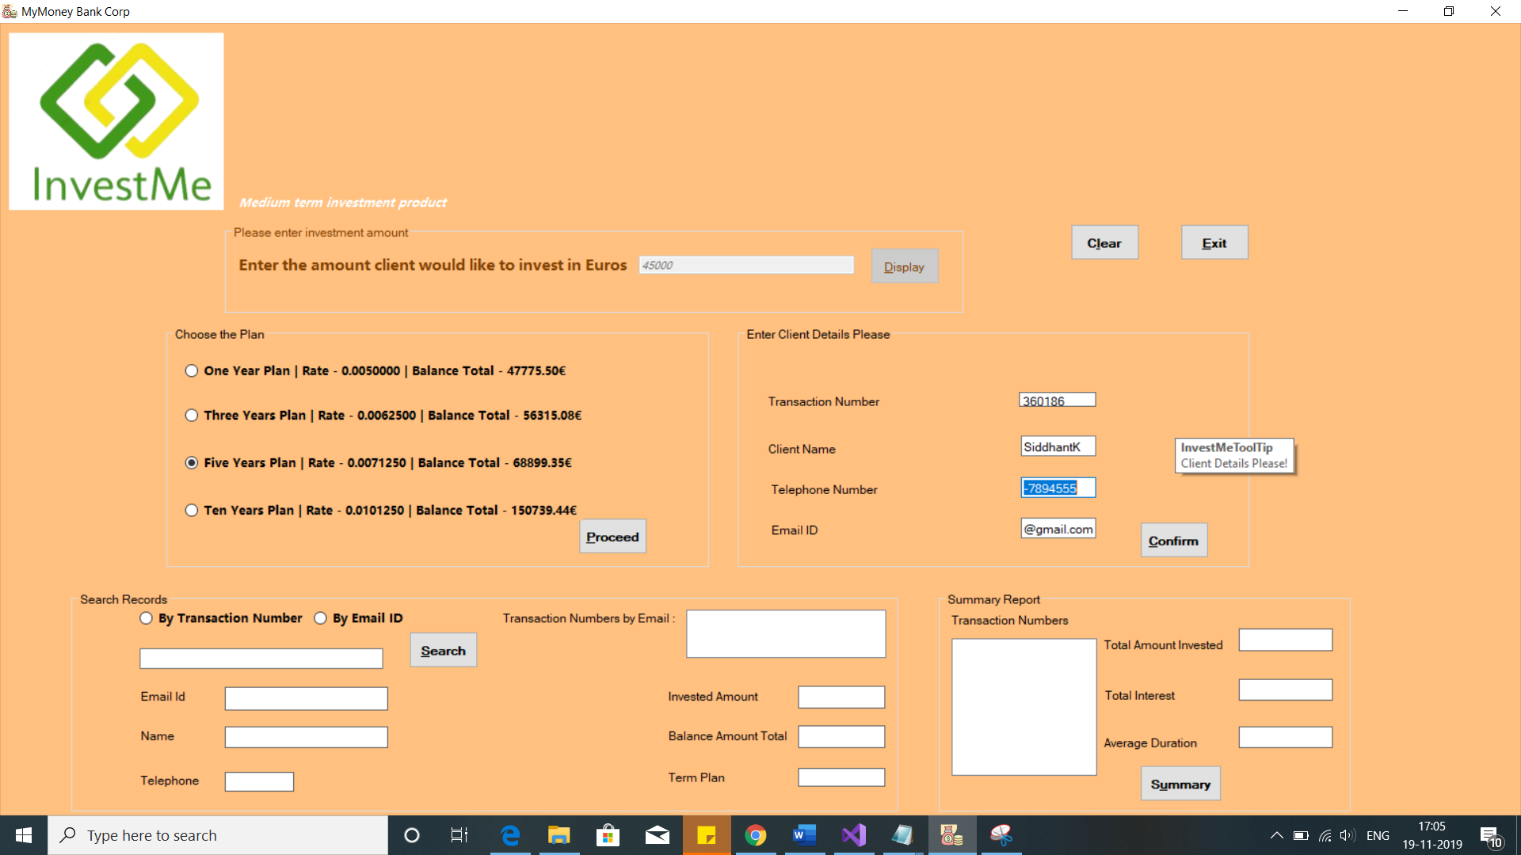

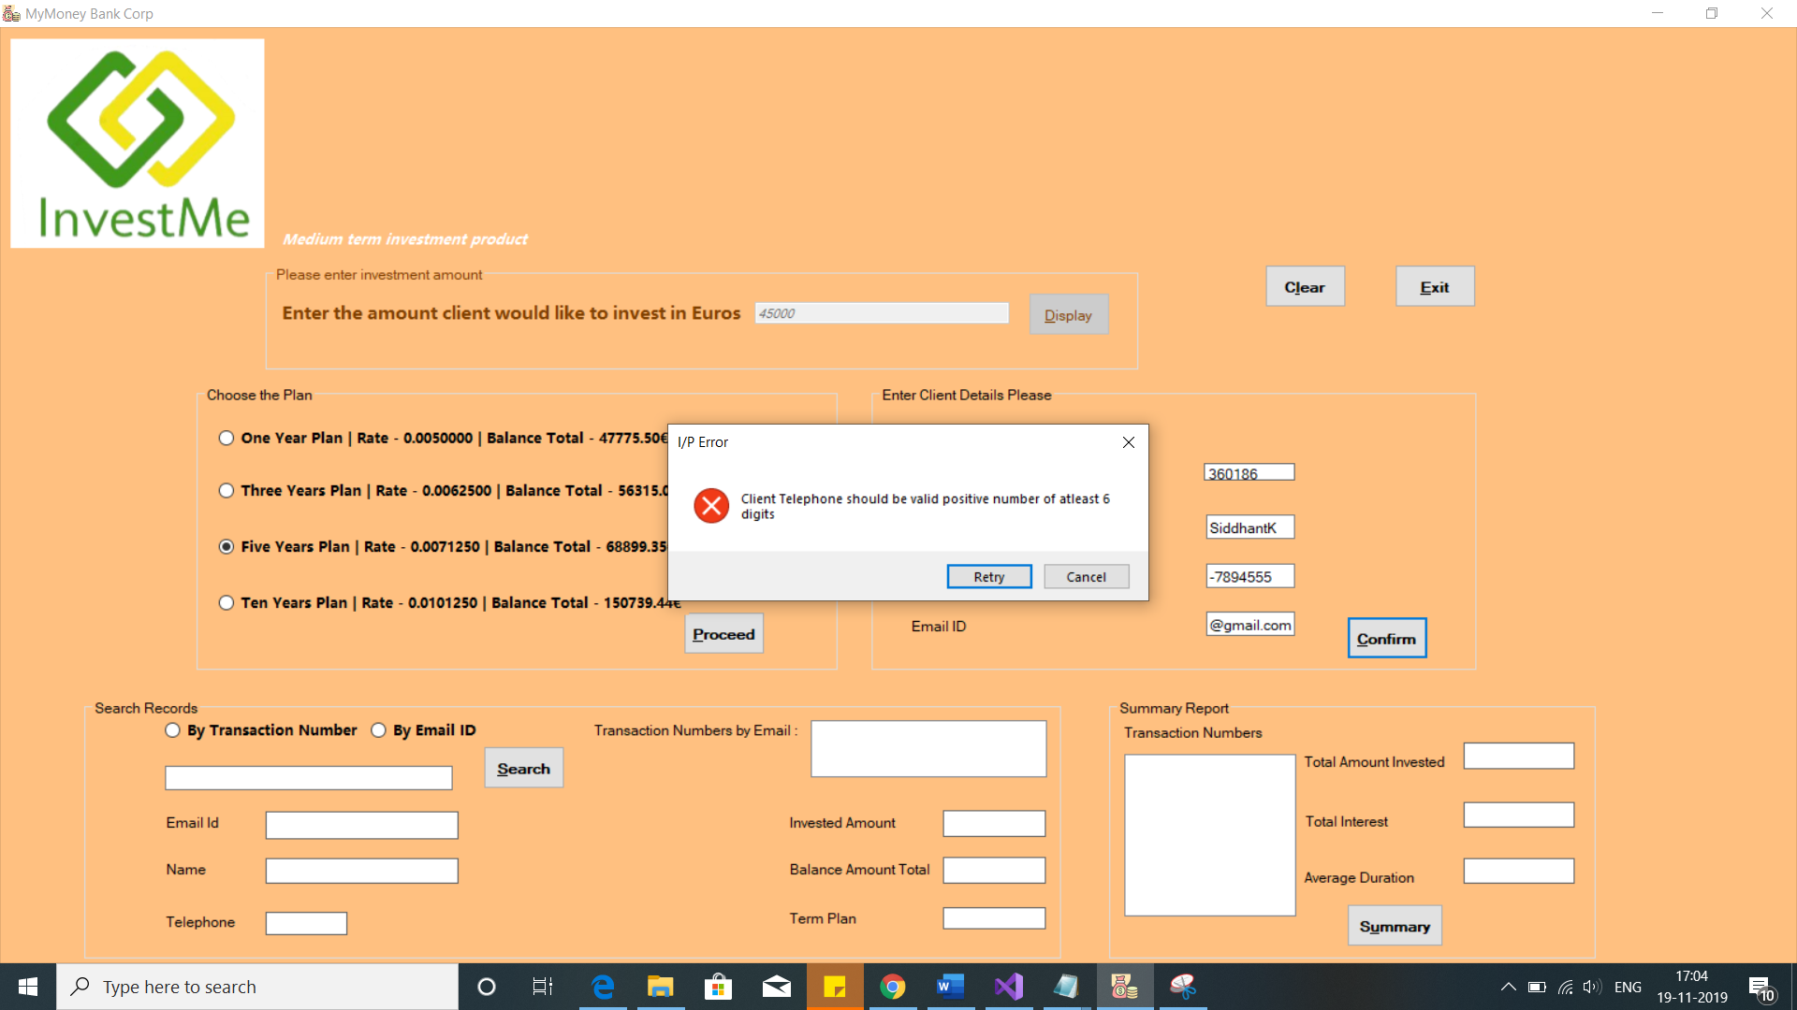

**Fig 18. In case user enters the non-numeric value in the telephone number the error message is shown. Also check has been placed to check the length of input as well as decimal or negative number entry**

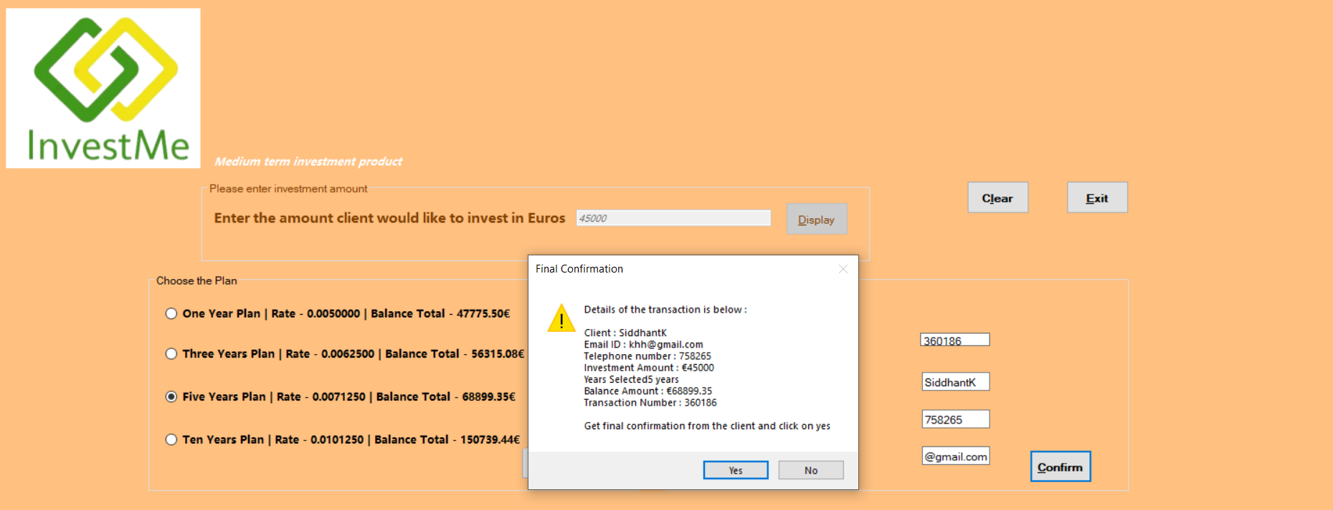

**Fig 19. After all input user validation when user clicks on confirm the application shows the detail of each transaction before final confirmation. The message box ask user to get final confirmation from the client and click on Yes to proceed**

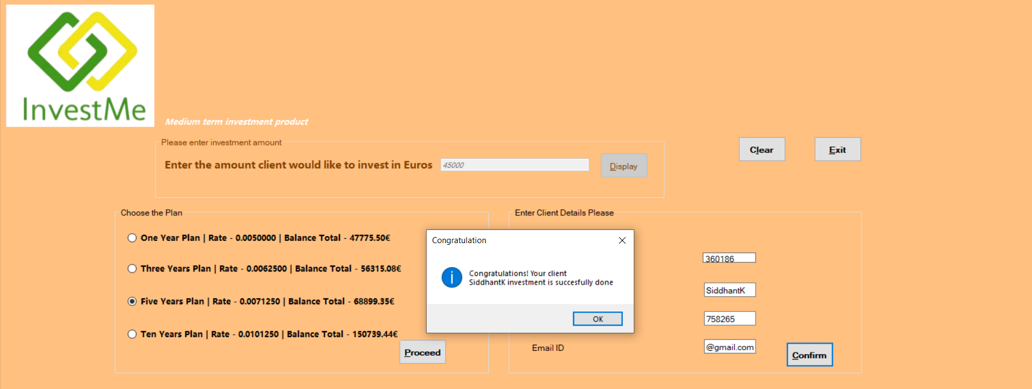

**Fig 20. After click on Yes the congration message box is shown and the transaction is processed. On click of Ok button the application gets ready for the new transaction and focus is set to the investment amount text box**

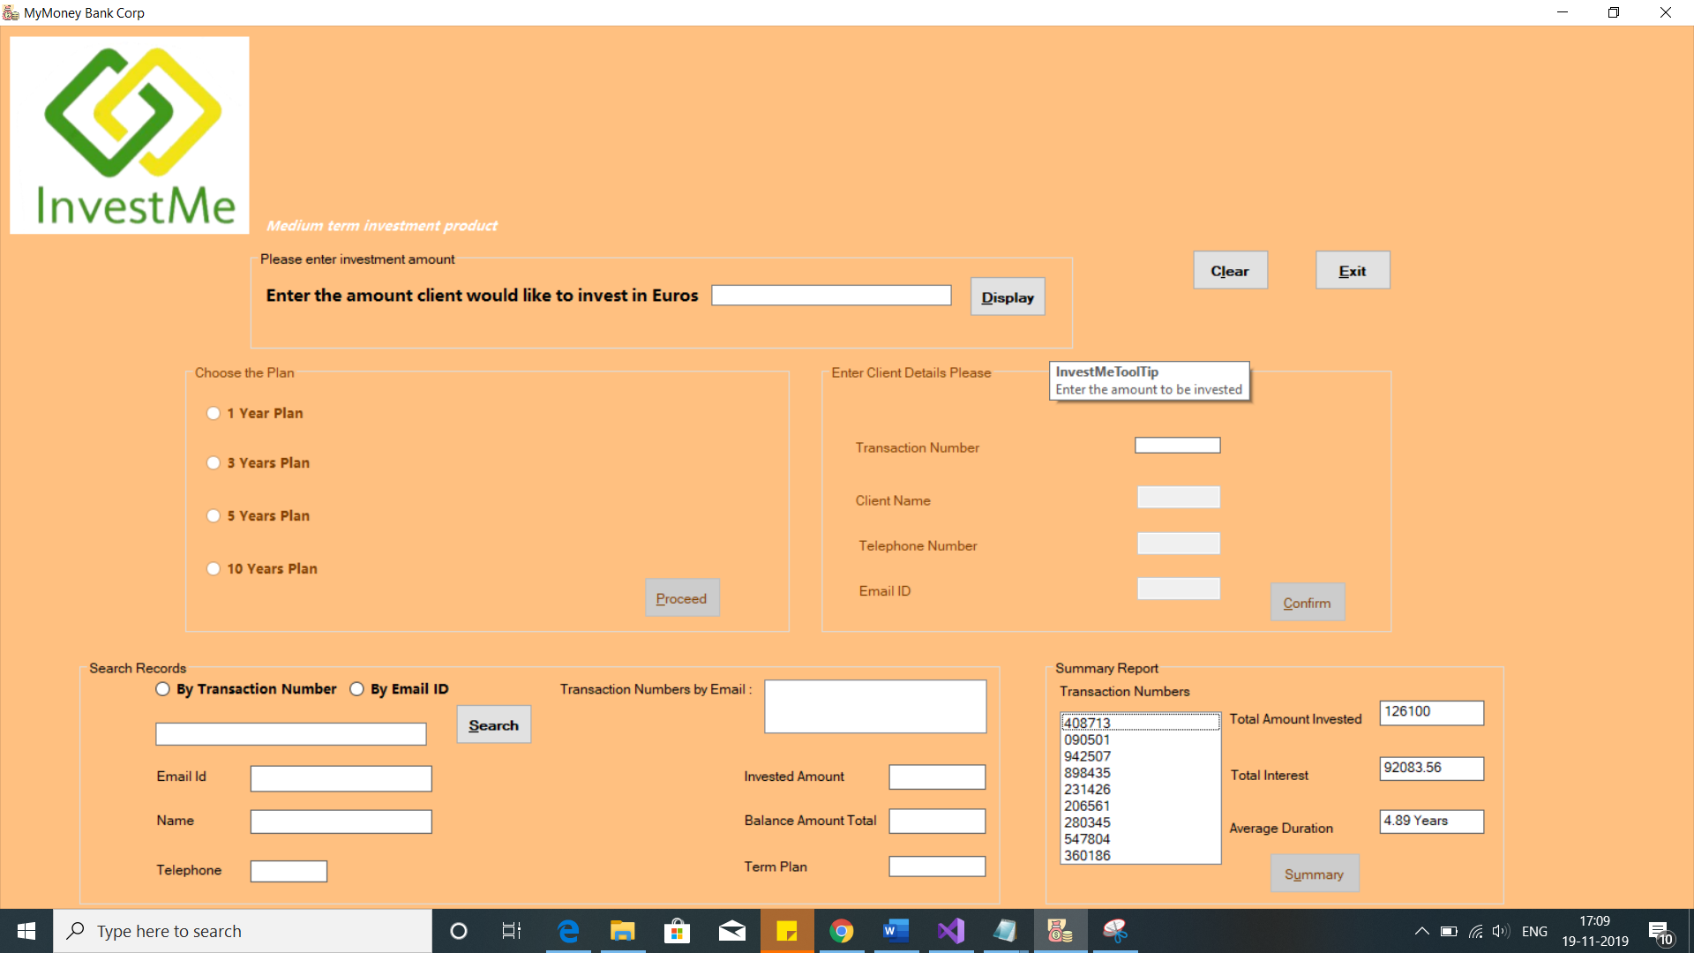

**Fig 21. On the successful transaction the user is set back to another transaction to avoid any delay**

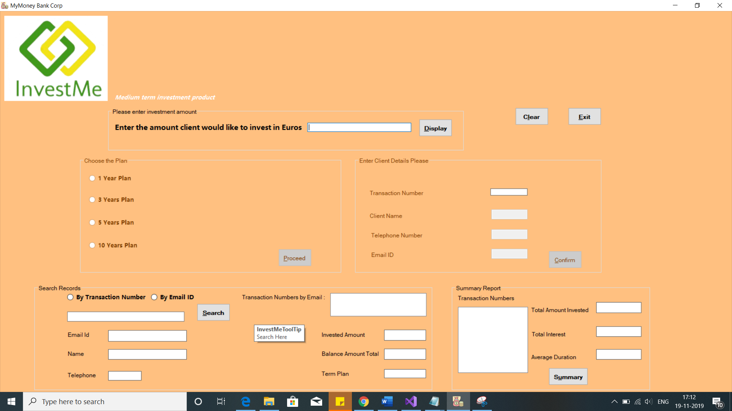

**Fig 22. On click of Clear button**

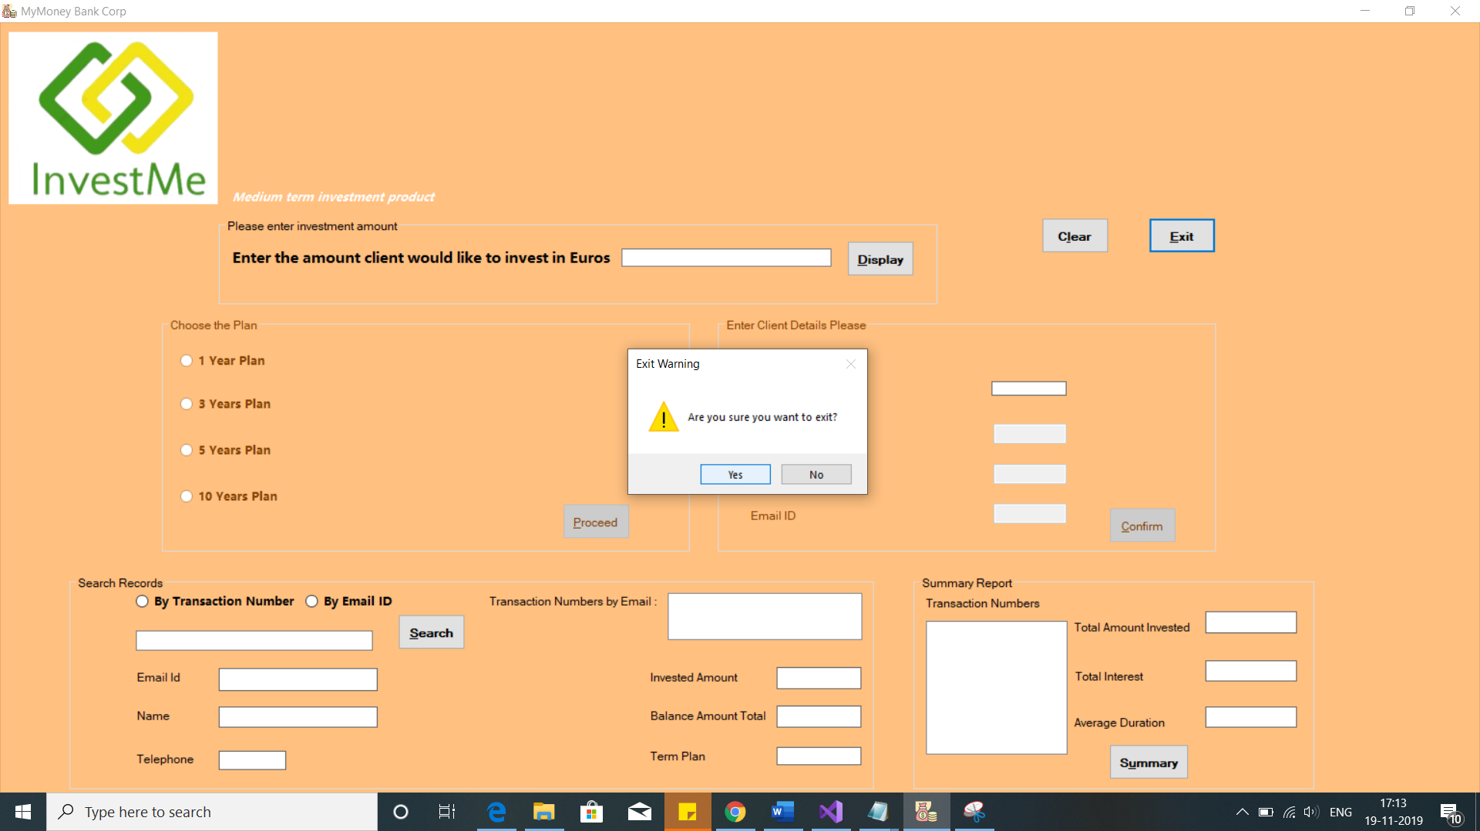

**Fig 23. Click of Exit button pops up the message to confirm with user if the application really needs to be closed**